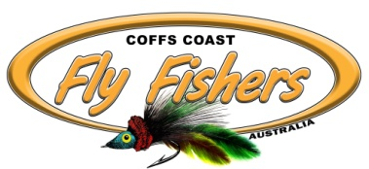
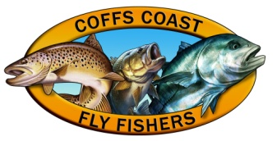
Coffs Coast Fly Fishing Club Inc
Members Survey 2018

Please complete this survey to help us plan the future of the club. Your views are important.

Club Membership
1. How did you find out about the club?
Please ✓ Friend ( ) newspaper ( ) Club Newsletter ( ) Facebook ( ) Internet ( )
Other ___________________________________________________

2. What can we do better to let more people know about the club?
________________________________________________________

3. What can we do better to make new members feels welcome?
__________________________________________________________

Club Meetings
4. What can we do better at meetings?
__________________________________________________________

__________________________________________________________

5. What guest speakers and activities would you like to have at meetings?
__________________________________________________________

__________________________________________________________

Outings and Activities
6. What day suits you best for club outings?
Please ✓all Saturdays ( ) Sundays ( ) Weekdays ( ) Public Holidays ( )
7. Do you want more multi day trips away? Please ✓ Yes ( ) No ( ) Maybe ( )
Where would you like to go for local or multi day trips?
__________________________________________________________

__________________________________________________________

Fly Tying
8. If you attend fly tying nights what can we do better?
__________________________________________________________

9. What flies would you like to learn to tie?
__________________________________________________________

Salt/Fresh Flyfishing
10. Are you a salt or freshwater flyfisher?  Salt ( ) Fresh ( ) You can ✓both.
11. Has the club got the balance between salt and fresh right?
Please ✓ Too much salt ( ) Balance about right ( ) Too much fresh ( )

Casting
12. If you want to be a better caster how important do you see the the club’s role in teaching casting?
Please ✓ Very Important ( ) Important ( ) Not Important ( )

13. Does your current casting abilities stop you catching fish or going on some outings? If so what can the club do to help?
__________________________________________________________

Communications
14. Do you follow us on Facebook Please ✓ Yes ( ) No ( )
15. Do you read our newsletter? Please ✓ Yes ( ) No ( )

16. What type of content would you like to see in our monthly newsletter?
__________________________________________________________

17. How could we encourage people to visit us on Facebook or our Web site?
__________________________________________________________

18. What can we do better to communicate what is happening at the club?
__________________________________________________________

Club Future
19. How would you like to see the club grow?
Please ✓ Many more members ( ) More members ( ) about right now ( ) too big now ( )

20. Compared to other clubs you may have belonged to how do we rate?
Please ✓ Above expectations ( ) on par ( ) below par ( )

21. What can we do to improve the club?
__________________________________________________________

__________________________________________________________

22. Are you prepared to take on an Executive/Committee role?
Please ✓Yes ( ) No ( ) Maybe in the future ( )
23. How can we raise more funds?
__________________________________________________________

24. How can we encourage more women and juniors to join?
_________________________________________________________

Home Waters
25. We have decided to adopt Bonville/Pine Creeks as our Home Waters. Would you be willing to help with any of the following?
Please ✓ Clean up Days ( ) Data Collecting ( ) Habitat Restoration ( )
Other _____________________________________________________

26. Should we investigate adopting a freshwater creek around Ebor as another Home Water?
Please ✓ Yes ( ) No ( ) Maybe ( )
27. If we adopted a freshwater creek would you be willing to help with?
Please ✓ Clean up Days ( ) Data Collecting ( ) Habitat Restoration ( ) Stocking ( )
Other _____________________________________________________

28. Final Comments: Anything you would like to add?

__________________________________________________________

